A Microprocessor-Controlled Autonomous Blimp
Section 4B
TA: Zhen Jia
Ian Pedowitz
Tom Piekos
Carlos Lazo
William Schmarder
December 9, 2005

Table of Contents
Introduction and Statement of Purpose 3
System Description and Development 3
Description of Hardware 4
Description of Software 6
Results and Conclusions 12
References 13
Appendices 14
Participation 31

Introduction and Statement of Purpose
This project is intended to further enhance our knowledge of the C8051F020 microprocessor and all associated components. Utilizing a microprocessor enabled car to test preliminary hardware and software components was necessary to prepare the group for flight navigation. Sensors such as an Electric Compass and an Ultrasonic Ranger provided external data into the system, enabling the altitude and steering systems to work as intended. Originally having been implemented separately, the sensors and individual LITEC pairs were merged – a heavy focus was placed upon team work and cooperation. The Smart Car made use of a proportional closed loop control algorithm for steering, and a proportional open loop control algorithm for speed control. To increase the overall efficiency of the control algorithms in preparation for the actual LITEC Blimp, proportional and derivative closed loop control algorithms were implemented on the gondola in bench top testing. With an accumulation of both circuitry and C code developed in the SiLabs IDE, along with corresponding output in HyperTerminal, and through much trial and error, we successfully integrated our embedded control system on a BAE Systems custom made Blimp.

System Description and Development
The hardware chosen for the blimp all serve a specific purpose towards the end goal of autonomous flight. The code developed controls all aspects of flight, as well as outputting requested information to the terminal. The following subsections describe the exact purpose of each component and code section.

Description of Hardware
The hardware used in this lab was picked to serve the requirements of the blimp. The components used on the blimp were a 74F365 Buffer, a SRF08 ultrasonic ranger, a CMPS03 digital compass, 2 1.8 kΩ pull-up resistors, 2 speed controllers, servo, a dipswitch, and several fans.
The purpose of the buffer is to prevent load from being placed on the EVB. The buffer does not allow current to flow from the load to the source, therefore preventing damage to the EVB from current. The buffer will present a digital high or low on the output if the input is high and low respectively; and also supply the needed current from a power supply that the load requires. This is needed since the speed controllers will draw more current than is able to be supplied from the EVB.
The purpose of the SRF08 ultrasonic ranger is to provide a distance from the bottom of the gondola to the floor. This is used when trying to have the blimp maintain a constant altitude. According to the data sheet, this ranger can accurately read distances from 3 cm to 6 m. This is more than enough accuracy for us to keep the blimp at about a height of 100-200cm. The range is read from the ranger using the I2C or SMBus.
The purpose of the CMPS03 electronic compass is to read the heading of the blimp. This is used when trying to have the blimp maintain a constant altitude. According the data sheet, the compass acquires a heading every 40ms. This is frequently enough for us to track the heading, since the blimp only rotates a few degrees per second in the air.
The 2 1.8 kΩ pull-up resistors are placed from the SDA line to +5V and SCL line to +5V. This allows the ranger and the compass to communicate over the SMBus. What would happen is if the ranger or compass wanted to send a digital one, it would bring its SDA pin to a high, causing a high impedance state on the pin. This would cause no current to flow across the resistor, which in turn means that there will be +5V on both sides of the resistor. The EVB would in turn read a digital high. If the ranger or compass wanted to send a digital zero, it would bring its SDA pin to a low, causing a ground state. This causes the SDA line to go to a digital low state and the EVB will read the digital low since it is connected in parallel with the resistor.
The purposes of the speed controllers are to control the speed of the fans. There are 2 speed controllers because we need one to control the speed of the thrust fans, and one to control the rudder fan. The speed controller is controlled with pulse width modulation, and based on the duty cycle of the wave, controls the speed of the fans.
The purpose of the servo is to control the thrust angle. The servo is connected to a dowel that goes to the fan shrouds, and depending on the position of the servo, it will rotate the dowel. The servo is also controlled using pulse width modulation, and the offset from the center of the servo is dependent on the duty cycle of the wave.
The purpose of the dipswitch is to provide 8 slide switches directly to Port 3. This makes it easy to flip switches controlling whether or not the fans were on, gain constants, etc… The purpose of the fans is to provide a control interface for the fan, so that it can control the heading and height.

Description of Software
The software for the blimp had to follow a specific set of requirements. These requirements were that the blimp had to be able to use PD control to get to, and maintain a specific height; as well as use PD control to get to, and maintain a specific heading. The main function controls the run sequence, and calls other functions when needed. The Port_Init function initializes all of the ports for input and output.
This code makes extensive use of precompiler definitions, and global variables. Definitions were used for constant values that were never changing. These are PCA_Start, and the minimum, maximum, and neutral pulse widths for the speed controller; minimum, and maximum pulse widths for the servo; and TRUE and FALSE being set to 1 and 0 for ease of use. The global variables used, and their description are as follows. nOverFlows is used to count the number of overflows, since we can use the PCA as a timer, since it overflows every 20 ms. The SERVO_PW_CENTER variable is used to store the calibrated center of the servo used to control the thrust angle. The THRUST_PW and SERVO_PW are used to store the thrust and thrust angle pulse widths respectively. The variable r_count is used as a “timer” to tell when it is time to get a range from the ranger. The variable h_count is used as a “timer” to tell when it is time to get a heading from the electronic compass. The variables new_range and new_heading are used as flags to tell when enough time has passed to read the range or heading. The variables range and heading are used to store what their names imply, so we can use them in more than one part of the code. The desired_range and desired_heading are set in the main function, and are the user’s choice of the desired range or heading. The previous_error_range and previois_error_heading are used to store the previous errors for use in the derivative portion of control. The variable STEER_PW is used to store the pulsewidth used by the speed controller on the rudder. The variables SS0 and SS1 are used to get a switch position from the dip switch on Port 3 pins 6 and 7 for use to decide whether to run the thrust or rudder fans respectively.
In Port_Init, Port 0 pins 6 and 7 are configured for input for serial communication between the ultrasonic ranger, and electric compass. Port 1 pin 4 is used for analog input to read the battery voltage. Port 1 pins 0, 1, and 2 are used to control the speed controllers, and servo motor. Port 3 pins 6 and 7 are used to control whether or not to run the thrust fans and rudder fans respectively.
The PCA_Init function initializes the programmable counter array for use in pulse width modulation. The clock source used is SYSCLK/12, and three capture and compare modules are set to 16 bit, enable compare, enable PWM. The function also enables the PCA interrupts, the PCA itself, and enables all interrupts.
The PCA_ISR function handles the type 9 interrupts generated from the PCA. It increments nOverFlows, r_count, and h_count. If r_count is greater than, or equal to 4, enough time has passed to read the ranger. If h_count is greater than, or equal to 2, enough time has passed to read the compass. In either case, we reset r/h_count, and set the respective flags to 1. In the ISR, we also set the low and high byte of the start count to PCA_Start, and reset the CF flag.
The SMB_Init function initializes the system management bus. This is used for serial communication over the I2C bus to the ranger, and compass. The SCL line is set to 100 kHz, and enables the SMBus.
The ADC_Init function initializes the analog to digital converter. The ADC used is ADC1. The first thing done is set it to use an internal reference voltage of 2.4V, enable the A/D converter, and set the analog gain to 1.
The Thrust_Angle_Calibration function is used to calibrate the thrust angle servo. Since the blimps are all custom made, the center position for each servo is different depending on the blimp. This function allows for the finding of the center position.
The Control_Hover function uses PD control to get to, and maintain a constant altitude. The first thing done in the function, is to check if enough time has passed for the ranger to complete its ping. If enough time has passed, it will then read the ranger. It then finds the error, which is the desired height, minus the actual height. We then use a temporary variable to store the pulse width. This is because the value may go out of bounds for the type used to store the pulse width. We then check to see if the value is within the allowable range, and if it is not, we set it to the upper or lower bound. Once this is done, we set the actual variable storing the pulse width to the temporary one, and set the capture and compare module to use this value. We then set the previous error to be the current error, so that in the next call of the function, we will be able to do the derivative portion of the PD control.
The Drive_Rudder control uses PD control to get to, and maintain a constant heading. The first thing done in the function, is to check if enough time has passed for the compass to acquire a heading. If enough time has passed, it will then read the compass. It then finds the error, which is the desired heading, minus the actual heading. We then check to see if error is greater than 1800, in which case we decrease it by 3600; or if the error is less than -1800, we increase it by 3600. This is to ensure that the error lies within the bounds of [-1800, 1800]. We then use a temporary variable to store the pulse width. This is for the same reason as above, and the value may go out of the range of the type of the variable used to store the pulse width. We then check to see if the value is within the allowable range, and if it is not, we set it to the upper or lower bound. Once this is done, we set the actual variable storing the pulse width to the temporary one, and set the capture and compare module to use this value. We then set the previous error to the current one so it can be used in the next call of the function in the derivative part of the control.
The Read_Ranger function makes use of the I2C bus for serial communication with the ultrasonic ranger. The first thing it does is declare a variable to be used as the buffer for communication. It then sends a read command on the I2C bus to the address of the ranger at register 2, for 2 bytes of data. It then calculates range based on the values inserted in to the buffer. We then reset the new_range flag so we do not attempt to read a range when the ranger is not ready. We then write 0x51 to the ranger at register 0 of the ranger, so as to tell it to begin pinging and give us the value in centimeters.
The Read_Compass function makes use of the I2C bus for serial communication with the electronic compass. The first thing it does is declare a variable to be used as the buffer for communication. It then sends a read command on the I2C bus to the address of the compass at register 2 for 2 bytes of data. The function then resets the new_heading flag so we do not attempt to read a heading when the compass is not ready to give us one. It then calculates the heading based on the values inserted in to the buffer.
The read_AD_input is used to read the result of the A/D conversion that took place. This is used in the code to find the voltage of the battery. The first step is to set P1.4 as the analog input. We then clear the “Conversion Completed” flag. Then we initiate the conversion. The function then waits for the conversion to complete, and returns the digital value in the ADC1 register.
The functions i2c_write_data and i2c_read_data make use of all of them I2C functions so we can read and write values to the ranger and compass using serial communication on the SMBus.
The main function controls the whole running of the code. The first thing done is to initialize the system. We then initialize the ports, PCA, SMBus, and ADC. Once this is done, we insert a default value in to the capture and compare modules so that the speed controllers are operating at neutral, and the servos pulse width is set somewhere between its two extremes. We then run the Thrust_Angle_calibration code so we can set the thrust fan shroud to point directly downwards so as to maximize the flow of air in that direction. This is in preparation for forward movement, which would take advantage of the shape of the shroud. We then prompt the user for their choice of headings, and range. Once they have made their selection, we reset the nOverFlows flag, and wait one second, so we can make sure that the speed controllers are initialized. We then reset the r/h_count variables, the new_range and new_heading flags, and nOverFlows. Once this is down, we enter the run loop of the program. If the slide switch on port 3 pin 6 is in the on position, then run the Control_Hover function. If the switch is in the off position, set the pulse width to the neutral pulse width so that the thrust fans turn off. If the slide switch on port 3 pin 7 is in the on position, then run the Control_Rudder function. If the switch is in the off position, set the pulse width to the neutral pulse width so that the rudder fan turns off. If nOverFlows is equal to 50, it means that one second has passed. If this is the case, print out the result of the analog to digital conversion so we can monitor the battery voltage.

The flowchart for the code is shown below:
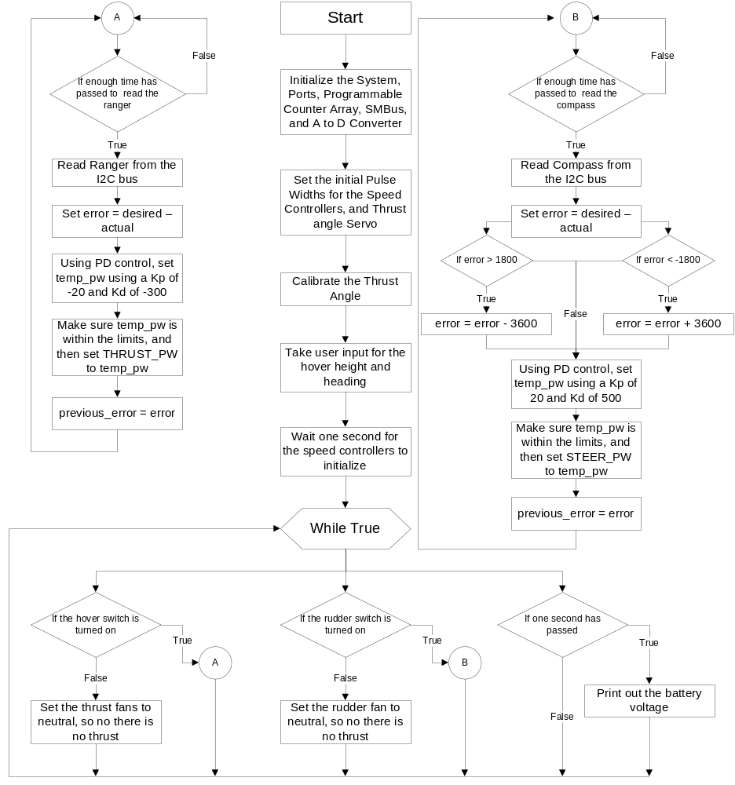
Figure 1: Flowchart for the run of the program

Results and Conclusions
Application of embedded control to a more real-world situation was the principle motivation behind this laboratory exercise. We initially were introduced us to the basics of Pulse Width Modulation (PWM), in addition to the correct usage of both the Ultrasonic Ranger and the Electronic Compass. We then learned how to effectively read and write data to and from these sensors. Once we had this information we were able to program the Smart Car for autonomous control based upon readings from both sensors (the Compass and Ranger). We then integrated the steering and speed subsystems onto one Smart Car, designed to travel along a heading specified at the beginning of the run. Once we had the Smart Car working with both sensors, we started porting our developed software to a different platform, namely the bench-top blimp hardware. Finally, we took this completed project and tested it on a fully working BAE Systems blimp once we had the gondola working on the blimp with PD control.
This project enabled us to demonstrate our mastery of topics covered earlier in LITEC, as well as our grasp of newer concepts such as PWM, control, Analog/Digital conversion, and the SMBus.
We ran into a few issues while coding and debugging. The largest hurdle we encountered involved finding the appropriate gain for the PD (proportional + derivative) control algorithm. We chose constants based on extensive trial and error testing, and were able to control the overshoot as well as the rise time by selecting the appropriate gains. Graphs relating to the trial and error process, specifically our attempts at calculating the appropriate constants for the PD control can be viewed in the appendices.
This project provided an effective way for us to demonstrate the skills that we have acquired in from beginning to end in LITEC. We ran into no severe problems and were able to successfully complete all that was required.

References
Laboratory Introduction to Embedded Control, lab manual v11.0. Troy, NY: Rensselaer Polytechnic Institute, 2005.

Appendices
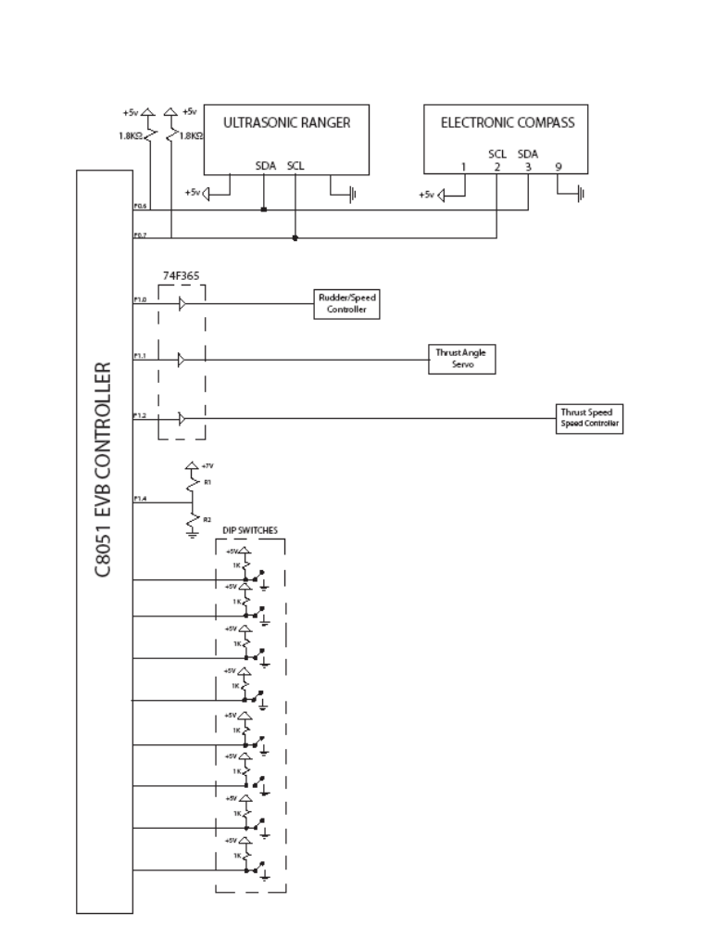
Figure 2: Circuit Schematic
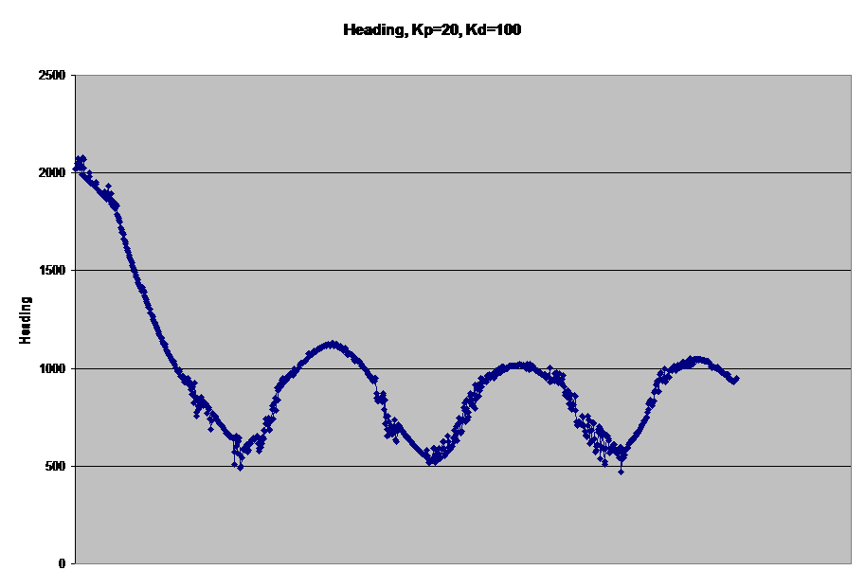
Figure 3: Graph showing bad values for K_{p} and K_{d} for heading control
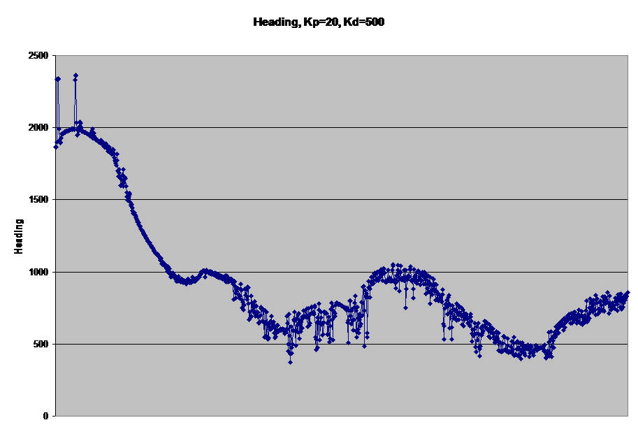
Figure 4: Graph showing good values for K_{p} and K_{d} for heading control
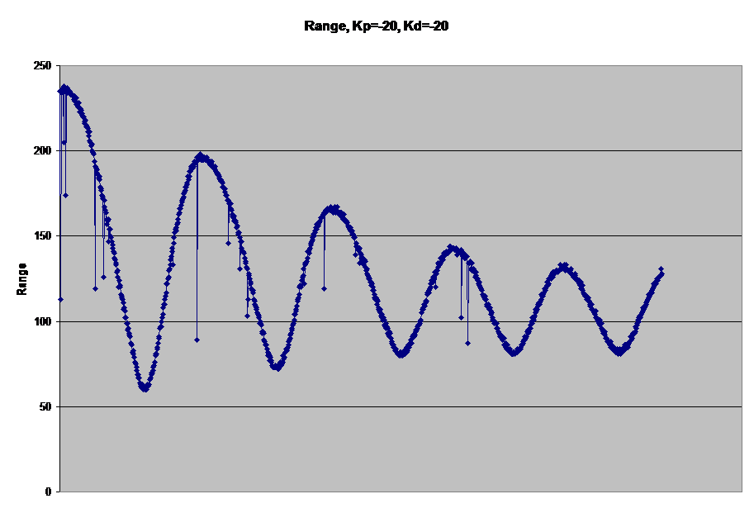
Figure 5: Graph showing bad values for K_{p} and K_{d} for hover control
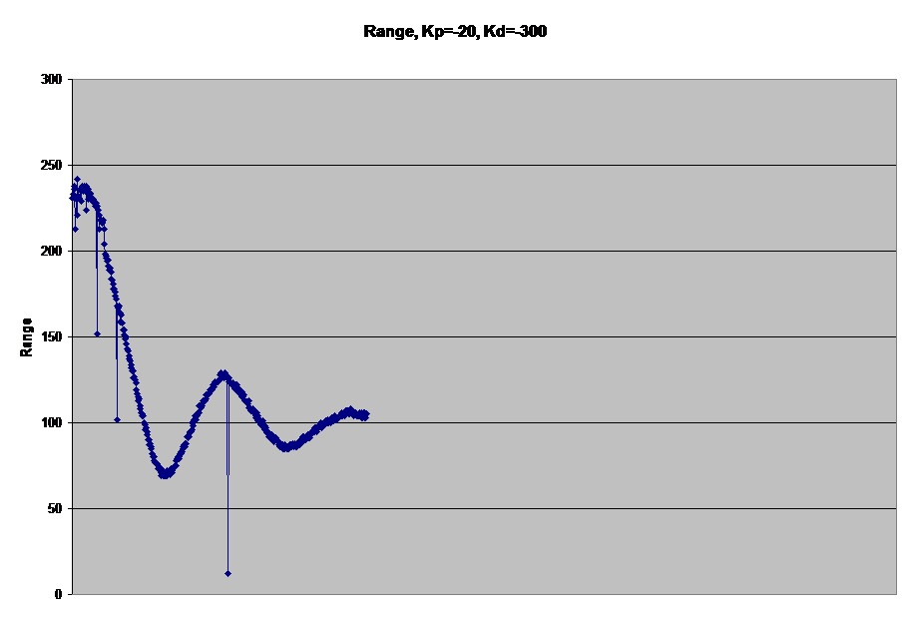
Figure 6: Graph showing good values for K_{p} and K_{d} for hover control

The source code for the blimp control is below:
// Ian Pedowitz, Tom Piekos, Carlos Lazo, and William Schmarder

#include <c8051.h>

#define PCA_start 28600 // Start count for PCA to have 20ms period

// Definitions for the thrust and rudder control
#define PW_MIN 2000 // Minimum pulsewidth for speed controllers
#define PW_MAX 3500 // Maximum pulsewidth for speed controllers
#define PW_NEUTRAL 2750 // Neutral pulsewidth for speed controllers

// Definitions for the thrust angle servo
#define SERVO_PW_MIN 2000 // Minimum pulewidtth for servo
#define SERVO_PW_MAX 3500 // Maximum pulsewidth for servo

#define TRUE 1 // Simple definitions for True and False
#define FALSE 0

//----------------------------------------------------------------------------------
// 8051 Initialization Functions
//----------------------------------------------------------------------------------
void Port_Init(void); // Function to initialize the Ports
void PCA_Init(void); // Function to initialize the PCA
void SMB_Init(void); // Function to initialize the SMBus
void ADC_Init(void); // Function to initialize the A to D converter

void Thrust_Angle_Calibration(void);
void Control_Hover(void); // Funtion which controls the hover of the blimp
void Drive_Rudder(void); // Function which controls the rudder

void Read_Ranger(void); // Function to read the range from the ranger
void Read_Compass(void); // Function to read the heading from the
// electronic compass
unsigned char read_AD_input(unsigned char n);

unsigned int nOverFlows = 0; // Variable to count the overflows

unsigned int SERVO_PW_CENTER = 2750; // Neutral pulsewidth for servo (in theory)
// Variables for the Thrust Control
unsigned int THRUST_PW = PW_NEUTRAL;// Pulsewidth for speed controller
unsigned int SERVO_PW = 2750; // Set the thrust angle to a known neutral value
unsigned char r_count = 0; // Variable to count the 80ms
unsigned char new_range = 0; // Flag for checking a new range
unsigned int range = 0; // Range from the ranger
int desired_range = 0;
int previous_error_range = 0;

// Variables for the Rudder Control
unsigned int STEER_PW = PW_NEUTRAL; // Pulsewidth for servo controller
unsigned char h_count = 0; // Variable used to count time before heading
unsigned char new_heading = 0; // Variable used to find if a new heading needs
// to be found
int desired_heading = 0; // Desired heading. This is user selectable
// by changing the value here
int heading = 0; // Heading from the electronic compass
int previous_error_heading = 0;

// Switches
sbit SS0 = P3^6; // Slide Switch to control whether or not to run
// the motor
sbit SS1 = P3^7; // Slide Switch to control whether or not to steer
// the car
//----------------------------------------------------------------------------------
// I2C Function Prototypes
//----------------------------------------------------------------------------------
void i2c_write_data(unsigned char addr, unsigned char start_reg, unsigned char* buffer, unsigned char num_bytes);
void i2c_read_data(unsigned char addr, unsigned char start_reg, unsigned char* buffer, unsigned char num_bytes);

//----------------------------------------------------------------------------------
// Main Function
//----------------------------------------------------------------------------------
void main(void)
{
char choice;
Sys_Init();
Port_Init();
PCA_Init();
SMB_Init();
ADC_Init();

PCA0CPL0 = 65535 - STEER_PW; // set initial pulse width
PCA0CPH0 = (65535 - STEER_PW) >> 8; // for the steering motor

PCA0CPL1 = 65535 - SERVO_PW; // set initial pulse width
PCA0CPH1 = (65535 - SERVO_PW) >> 8; // for the thrust angle servo

PCA0CPL2 = 65535 - THRUST_PW; // set initial pulse width
PCA0CPH2 = (65535 - THRUST_PW) >> 8; // for the thrust motor

Thrust_Angle_Calibration();

choice = '0';
while(choice != '1' && choice != '2' && choice != '3' && choice != '4')
{
printf("Please select a desired heading\n1) 0 degrees\n2) 90 degrees\n3) 180 degrees\n4) 270 degrees");
choice = (char)getchar();
}
if(choice == 1)
desired_heading = 0;
else if(choice == 2)
desired_heading = 900;
else if(choice == 3)
desired_heading = 1800;
else if(choice == 4)
desired_heading = 2700;

choice = '0';
while(choice != '1' && choice != '2' && choice != '3' && choice != '4')
{
printf("Please select a desired range\n1) 50 cm\n2) 100 cm\n3) 150 cm\n4) 200 cm");
choice = (char)getchar();
}
if(choice == 1)
desired_range = 50;
else if(choice == 2)
desired_range = 100;
else if(choice == 3)
desired_range = 150;
else if(choice == 4)
desired_range = 200;

nOverFlows = 0;

while(nOverFlows <= 50); // Wait one second

r_count = 0; // reset the count for 80ms
new_range = 0; // reset the new_range flag

h_count = 0; // reset the count for 40ms
new_heading = 0; // reset the new_heading flag

nOverFlows = 0; // reset nOverFlows so we can use it
// to time a second

while(1)
{
if(!SS0)
Control_Hover();
else
{
THRUST_PW = 2750;
PCA0CPL2 = 65535 - THRUST_PW;
PCA0CPH2 = (65535 - THRUST_PW) >> 8;
}

if(!SS1)
Drive_Rudder();
else
{
STEER_PW = PW_NEUTRAL;
PCA0CPL0 = 65535 - STEER_PW;
PCA0CPH0 = (65535 - STEER_PW) >> 8;
}

if(nOverFlows == 50) // If a second has passed, print out
{ // the battery voltage
printf("\nThe AD conversion result is %bu", read_AD_input(5));
nOverFlows = 0;
}
}
}

//----------------------------------------------------------------------------------
// Thrust_Angle_Calibration
//----------------------------------------------------------------------------------
//
// Function which calibrates the thrust angle
//
void Thrust_Angle_Calibration(void)
{
char choice;
while(choice != 'c')
{
printf("\nEnter u, or d");
choice = getchar();
if(choice == 'u')
SERVO_PW += 10;
else if(choice == 'd')
SERVO_PW -= 10;

if(SERVO_PW > SERVO_PW_MAX)
SERVO_PW = SERVO_PW_MAX;
else if(SERVO_PW < SERVO_PW_MIN)
SERVO_PW = SERVO_PW_MIN;

PCA0CPL1 = 65535 - SERVO_PW;
PCA0CPH1 = (65535 - SERVO_PW) >> 8;
}
}
//----------------------------------------------------------------------------------
// Control_Hover
//----------------------------------------------------------------------------------
//
// Function which controls the hover of the blimp
//
void Control_Hover(void)
{
long temp_pw = 0;
int error = 0;

if(new_range) // If enough time has passed to read a new
{ // range, run this code
Read_Ranger();

error = desired_range - range; // Find the error between the desired and actual

temp_pw = (-20)*(long)error + (-300)*((long)error - previous_error_range) + PW_NEUTRAL;

if(temp_pw > PW_MAX) // If the pulsewidth is out of the allowed range
temp_pw = PW_MAX; // set the value to the limit
else if(temp_pw < PW_MIN)
temp_pw = PW_MIN;

THRUST_PW = temp_pw;
PCA0CPL2 = 65535 - THRUST_PW;
PCA0CPH2 = (65535 - THRUST_PW) >> 8;

previous_error_range = error; // Set the previous error to use in the
// derivative control
}
}

//----------------------------------------------------------------------------------
// Drive_Rudder
//----------------------------------------------------------------------------------
//
// Function which controls the rudder
//
void Drive_Rudder(void)
{
long temp_pw = 0;
int error = 0;

if(new_heading) // If enough time has passed to read a new
{ // heading, run this code
Read_Compass();
printf("\n%d", heading);

error = desired_heading - heading; // Find the error between the desired
// and the actual
if(error > 1800) // If the error is greater than 1800
error -= 3600; // decrease it by 3600 so we have a range
// of errors that is [-1800, 1800]

if(error < -1800) // If the error is less than 1800
error += 3600; // increase it by 3600 so we have a range
// of errors that is [-1800, 1800]

temp_pw = (20)*(long)error + (500)*((long)error - previous_error_heading) + PW_NEUTRAL;

if(temp_pw > PW_MAX) // If the pulsewidth is out of the allowed range
temp_pw = PW_MAX; // set the value to the limit
else if(temp_pw < PW_MIN)
temp_pw = PW_MIN;

STEER_PW = temp_pw;
PCA0CPL0 = 65535 - STEER_PW;
PCA0CPH0 = (65535 - STEER_PW) >> 8;

previous_error_heading = error; // Set the previous error to use in the
} // Derivative control
}

//----------------------------------------------------------------------------------
// Read_Ranger
//----------------------------------------------------------------------------------
//
// Function to read the range from the ultrasonic ranger
//
void Read_Ranger(void)
{
unsigned char buffer[2];
unsigned char addr = 0xE0; // The address of the ranger is the 0xE0

i2c_read_data(addr, 2, buffer, 2); // read 2 bytes starting at reg 2
range = (((unsigned int)buffer[0] << 8) | buffer[1]);
new_range = 0; // reset 80ms flag

buffer[0] = 0x51; // Set the first byte of the buffer to
// 0x51 so the output is in cm
i2c_write_data(addr, 0, buffer, 1); // Write one byte of data to reg 0
}

//----------------------------------------------------------------------------------
// Read_Compass
//----------------------------------------------------------------------------------
//
// Function to read the heading from the ultrasonic ranger
//

void Read_Compass(void)
{
unsigned char addr = 0xC0; // the address of the sensor, 0xC0 for the compass
unsigned char Data[2]; // Data is an array with a length of 2

i2c_read_data(addr, 2, Data, 2); // read two byte, starting at reg 2
new_heading = 0;
heading =(((unsigned int)Data[0] << 8) | Data[1]); //combine the two values
//heading has units of 1/10 of a degree
}

//----------------------------------------------------------------------------------
// Port_Init
//----------------------------------------------------------------------------------
//
// Set up port for input and output
//
void Port_Init(void)
{
P0MDOUT &= ~0xC0; // Port 0, pins 6 and 7 are used for
// serial communication so set them
// to open drain mode
P0 |= 0xC0; // Set Port 0, pins 6 and 7 to
// high impedence state

P1MDIN &= ~0x20; // Set P1.4 for analog input
P1MDOUT &= ~0x20; // Set P1.4 to open drain mode
P1 |= 0x02; // Send logic 1 to input pin P1.4

P1MDOUT |= 0x07; // Port 1, pins 0, 1 and 2 are used for
// output to the steering system and
// driving systems respectively

P3MDOUT &= ~0xC0; // Set input pins P3.6-7 in open drain mode
P3 |= 0xC0; // Set input pins P3.6-7 to high impedance state

XBR0 = 0x27; // Set up UART0, SPI, SMB, CEX0-3
}

//----------------------------------------------------------------------------------
// PCA_Init
//----------------------------------------------------------------------------------
//
// Set up Programmable Counter Array
//
void PCA_Init(void)
{
PCA0MD = 0x81; // SYSCLK/12, enable CF interrupts, suspend when idle
PCA0CPM0 = 0xC2; // 16 bit, enable compare, enable PWM - Rudder fan speed
PCA0CPM1 = 0xC2; // 16 bit, enable compare, enable PWM - Thrust fan angle
PCA0CPM2 = 0xC2; // 16 bit, enable compare, enable PWM - Thrust fan speed
EIE1 |= 0x08; // enable PCA_interrupts
PCA0CN |= 0x40; // enable PCA
EA = 1; // enable all interrupts
}

//----------------------------------------------------------------------------------
// SMB_Init
//----------------------------------------------------------------------------------
//
// Set up System Management Bus
//
void SMB_Init(void)
{
SMB0CR=0x93; // Set SCL to 100KHz
ENSMB=1; // Bit 6 of SMB0CN, enable the SMBus
}

//----------------------------------------------------------------------------------
// ADC_Init
//----------------------------------------------------------------------------------
//
// Set up Analog to Digital Converter
//
void ADC_Init(void)
{
REF0CN = 0x03; // Set Vref to use internal reference voltage (2.4 V)
ADC1CN = 0x80; // Enable A/D converter (ADC1)
ADC1CF |= 0x01; // Set A/D converter gain to 1
}

//----------------------------------------------------------------------------------
// read_AD_input
//----------------------------------------------------------------------------------
//
// Function to read the input off the ADC
//
unsigned char read_AD_input(unsigned char n)
{
AMX1SL = n; // Set P1.n as the analog input for ADC1
ADC1CN = ADC1CN & ~0x20; // Clear the "Conversion Completed" flag
ADC1CN = ADC1CN | 0x10; // Inititate A/D conversion

while((ADC1CN & 0x20) == 0x00); // Wait for conversion to complete

return ADC1; // Return digital value in ADC1 register
}

//----------------------------------------------------------------------------------
// PCA_ISR
//----------------------------------------------------------------------------------
//
// Interrupt Service Routine for Programmable Counter Array Overflow Interrupts
//
void PCA_ISR(void) interrupt 9
{
if(CF)
{
nOverFlows++; // Increment nOverFlows. This acts as a timer that
// overflows every 20ms

r_count++;
if(r_count >= 4)
{
new_range = 1; // 4 overflows is about 80ms
r_count = 0;
}

h_count++;
if (h_count >= 2)
{
new_heading = 1;
h_count = 0;
}

PCA0L = PCA_start; // low byte of start count
PCA0H = PCA_start >> 8; // high byte of start count
CF = 0;
}
else
{
PCA0CN &= 0xC0; // all other type 9 interrupts
}
}

//----------------------------------------------------------------------------------
// Serial I/O
//----------------------------------------------------------------------------------

//----------------------------------------------------------------------------------
// Routine: i2c_read
// Inputs: none
// Outputs: input byte
// Purpose: Reads data from the I2C bus
//----------------------------------------------------------------------------------
unsigned char i2c_read(void)
{
unsigned char input_data;

while(!SI); // Wait until we have data to read
input_data = SMB0DAT; // Read the data
SI = 0; // Clear SI
return input_data; // Return the read data
}

//----------------------------------------------------------------------------------
// Routine: i2c_read_and_stop
// Inputs: none
// Outputs: input byte
// Purpose: Sends I2C Stop Transfer
//----------------------------------------------------------------------------------
unsigned char i2c_read_and_stop(void)
{
unsigned char input_data;

while(!SI); // Wait until we have data to read
input_data = SMB0DAT; // Read the data
SI = 0; // Clear SI
STO = TRUE; // Perform I2C stop
while(!SI); // Wait for stop
SI = 0;
return input_data; // Return the read data
}

//----------------------------------------------------------------------------------
// Routine: i2c_start
// Inputs: none
// Outputs: none
// Purpose: Sends I2C Start Transfer
//----------------------------------------------------------------------------------
void i2c_start(void)
{
while(BUSY); // Wait until the SMBus0 is free
STA = TRUE; // Set Start bit
while(!SI); // Wait until start send (look at SI)
STA = FALSE; // Clear Start bit
SI = 0; // Clear SI
}

//----------------------------------------------------------------------------------
// Routine: i2c_write
// Inputs: output byte
// Outputs: none
// Purpose: Writes data over the I2C bus
//----------------------------------------------------------------------------------
void i2c_write(unsigned char output_data)
{
SMB0DAT = output_data; // Store data in SMB0DAT register
while(!SI); // Wait until we are done with send
SI = 0;
}

//----------------------------------------------------------------------------------
// Routine: i2c_write_and_stop
// Inputs: output byte
// Outputs: none
// Purpose: Sends I2C Stop Transfer
//----------------------------------------------------------------------------------
void i2c_write_and_stop(unsigned char output_data)
{
SMB0DAT = output_data; // Store data in SMB0DAT register
STO = TRUE; // Set Stop bit
while(!SI); // Wait until we are done with send
SI = 0; // Clear SI
}

//----------------------------------------------------------------------------------
// Routine: i2c_write_data
// Inputs: unsigned char addrs - address of the device that will be written to
// unsigned char start_reg - first register that will be written
// unsigned char* buffer - array of data to be written
// unsigned char num_bytes - number of elements in the array
// Outputs: none
// Purpose: Write data to the I2C bus
//----------------------------------------------------------------------------------
void i2c_write_data(unsigned char addr, unsigned char start_reg, unsigned char* buffer, unsigned char num_bytes)
{
unsigned char c;

i2c_start(); // Start I2C transfer
i2c_write(addr & 0xFE); // Write address of device that will be written to
i2c_write(start_reg); // Write the start register

for(c = 0; c < num_bytes - 1; c++)
i2c_write(buffer[c]); //Write all bytes in the buffer except for the last one
i2c_write_and_stop(buffer[c]); // Write the last byte and stop
}

//----------------------------------------------------------------------------------
// Routine: i2c_read_data
// Inputs: unsigned char addr - the address of the device to read from
// unsigned char start_reg - the first register to read from
// unsigned char* buffer - array where the read data will be stored
// unsigned char num_bytes - number of bytes to be read from device
// Outputs: none
// Purpose: Read data from the I2C bus
//----------------------------------------------------------------------------------
void i2c_read_data(unsigned char addr, unsigned char start_reg, unsigned char* buffer, unsigned char num_bytes)
{
unsigned char c;

i2c_start(); // Start I2C transfer
i2c_write(addr & 0xFE); // Write address of the device to read from
i2c_write_and_stop(start_reg); // Write the first register to be read and stop

i2c_start(); // Start I2C transfer
i2c_write(addr | 0x01); // Write address again, this time indicating read operation
for(c = 0; c < num_bytes - 1; c++)
{
AA = 1; // Set acknowledge bit
buffer[c] = i2c_read(); // Read data, save it in the buffer
}
AA = 0; // Clear acknowledge bit
buffer[c] = i2c_read_and_stop(); // Read the last byte and stop, save it in the buffer
}

Participation
Introduction and Statement of Purpose: Carlos Lazo
System description and development: Ian Pedowitz
Description of Hardware: Ian Pedowitz
Description of Software: Ian Pedowitz
Flowchart: William Schmarder
Results and conclusions: Tom Piekos
List of references: Everyone
Appendices: Everyone
Circuit Schematic: Tom Piekos

This list represents who did the majority of the work for each section. But, during all Labs all four partners were present and working together towards the completion.

Ian Pedowitz x_________________________
Tom Piekos x_________________________
Carlos Lazo x_________________________
William Schmarder x_________________________

